**Brought to You By: The Role of Digital Spaces in Promoting**

**Mental Health Resources to College Students**

Abbey Willmann and Chip Verst

Dr. Stephen Haas

University of Cincinnati

April 21, 2024

Social media has been the subject of much scrutiny over the past decade, especially in regard to its effects on mental health. While originally designed as a tool to connect individuals, social media platforms rapidly altered to a landscape of anonymity and a means of voicing opinions with little to no oversight or backlash. However, recent efforts to crack down on cyber bullying and campaigns to make social media spaces safer for their users have evolved the platforms once again. Rather than a breeding ground for cyber bullying, recent efforts have caused a turnaround in the discussions of mental health in digital spaces.

Much of previous research has focused on the types of online communities used for mental health discussions, yet more can be learned about mental health issues on social media and online advertising. Other digital platforms, such as podcasting and online streaming services like YouTube, have promoted access to mental health-related resources. Companies such as BetterHelp and Talk Space frequently sponsor content creators to both advertise their services as well as create an open dialogue for discussing mental health struggles online. This shift in online user experience opens questions pertaining to the effectiveness of these resource outreach strategies, as young or financially vulnerable individuals continue to rely on accessible information-seeking technologies. This study explores the perceptions of college-age individuals regarding their experiences and evaluations of online mental health-based advertisements and how user frequency interacts with certain perceptions of these promotions.

**Literature Review**

While social media has been found to be a source of mental health detriments, it is evolving to include open and honest discussion of mental health problems as well and creating a space for obtaining appropriate resources (Gabarron et al., 2023; Shepherd et al., 2015). When discussing the role of digital spaces in the conversations around mental health, many digital landscapes that are analyzed are those of social media platforms such as Facebook, Instagram, and Twitter (now ‘X’) or online communities such as Reddit and Discord, etc. By looking at the ways users of these spaces interact in and utilize the space, the effects of marketing tactics used by companies providing mental health services and resources can be better understood. .

Recently, digital forums, including podcasts, have expanded to not only serve as discussion boards about mental health, but also include the dissemination of crucial resources such as support groups and access to online therapy. This trend may serve as both a predatory tactic which capitalizes on vulnerable groups and a means of supplying support for groups who may not traditionally have access to mental health resources. The existing research generally shows social media as a beneficial space for interaction about and with mental health resources, and this study aims to explore further how technology is perceived and being used in the discussion of mental health online. To gain insight into the effects of mental health resource access online, it is important to understand the perceptions that social media users have about their access, or lack thereof. This will help guide understanding regarding the perceptions users have about their ability to access these resources and how that impacts their feelings about accessibility.

To gain insight into the ways users of social media utilize the communal nature of various platforms, Naslund et al. (2017) surveyed users of Twitter and found that a significant portion of their respondents (85%) expressed interest in accessing mental health resources that were provided via social media platforms. Participants were asked to disclose several key personal demographic characteristics which included information such as: disclosure of mental illness, average social media usage, and the reported purposes of using social media (Naslund et al., 2017). While Twitter (X) is a forum that encourages interaction between users, its character restriction on posts can impact the effectiveness of dialogue between users, which is why longer form social media services such as Instagram and Facebook, and forum sites such as Reddit are able to provide unique perspectives on the support services available in the digital space.

Naslund et al. (2017) found the primary motivator for many of the respondent's’ social media usage to be the accessing and utilizing of peer support. Also, the majority (85%) mentioned that they would be interested in programs advertised through social media that were designed to help individuals with mental illnesses; with the two most popular services of interest being that of overall health/wellbeing and programs for coping with mental health systems (Naslund et al., 2017). Many of the respondents had a diversity in geographical background, supporting the idea that the discussion of mental health in online spaces is one that can be conducted across cultures and can focus on multiple online communication forums and social media sites. Gabarron et al. (2023) found depression and anxiety were the most frequent points of discussion on social media regarding mental health, in addition to women’s health. In assessing 458 studies, they also found adult (39.5%) and parent (33.4%) discussions of mental health topics on services such as Facebook, WhatsApp, and Instagram were most common (Gabarron et al., 2023).

**The Role of Online Forums**

The digital space is ever shifting and is always adapting to the needs of its users and community members. As a result, different types of online forums attract users for diverse reasons. For example, Shepherd et al. (2015) analyzed conversations on Twitter and the use of hashtags (a unique method of conversation tracking similar to the forum thread method used Reddit). They found that social media spheres could not only serve as positive avenues for communication for patients, but that there is increasing potential of benefit for mental health professionals to utilize them for a more collaborative relationship with their patients. Online forums also have been a long running ‘digital commons’ offering a more community-focused approach to online communication. It is the popularity of sites~~,~~ such as Reddit, and the rise of other online spaces (such as podcasts) that have aided in expansion beyond social media for discussion of mental health in digital spaces. Online communities also provide other venues for topics like mental health to be discussed among peers. While podcasts create access to resources via sponsorships, Reddit forums provide more of a community-oriented means of interaction.

For instance, Reddit has been studied for it’s potential as a platform for mental health communication between users (Gkotsis et al., 2016). Shepherd et al.~~,~~ 2015) collected posts~~,~~ and organized them by categories based on what aspects of mental health were being discussed by pulling information from “subreddits” (sub-communities) related to specific aspects of mental health. Subreddits are threads categorized within the app to provide an internal organization to conversations centered around specific topics. They found the depression subreddit had the most participation with 1.1 million posts, and the least (5.5 thousand) belonged to ‘BipolarSO’s’ (Gkotsis et al., 2016). Research like this underscores that people are searching for and discussing mental health issues, but there can be differences in how these online communities are being used. While some subreddits foster community of support, this is not the majority (Gkotsis et al., 2016). Instead, many subreddits seem to segment online users into siloed groups that offer forums to interact with others on specific topics. It is this diversity of experience that calls to question both the intentions and the outcomes of mental health discussions in online forums. Similarly to the intentions of users online, corporations providing access to mental health resources do not always have the interests of the user at heart. Ultimately, the success of a service is creating access to it which can be seen as predatory under certain circumstances. As the interests of users have shifted in recent years, it has created new avenues for users online to interact with the efforts of advertisers.

Another digital platform that has grown considerably in recent years has been that of the podcast sphere. During the COVID-19 pandemic, some individuals who were homebound turned to podcasts for entertainment. COVID also provided many communication-related challenges as well. Abbas et al. (2021) explored the use of podcasts as a means of providing social support and found that “Social media provided platforms to seek health information for those who desired health related information in the outbreak of the COVID-19" (Abbas et al., 2021, p.1927). Their insights focused on access to information on physical health related to the pandemic. Their findings suggest thinking more deeply about how the pandemic continues to affect the consumption of digital media and participation in online communities.

**Promoting Access to Mental Health Services**

Digital communal spaces have become a means of sharing and promoting mental health resources and discussions. While peer-to-peer support of mental health care is seemingly encouraged by online users (Naslund et al., 2016), the promotion of corporate or professional services has received skepticism from online users (Ford et al., 2019). For corporate or professional services, advertising strategy plays an important role in gathering the attention of online users. Understanding the engagement habits of users who may suffer from major depression and similar mental health disorders can provide companies with the ability to funnel their money and resources to consumers most likely to interact with relevant resource content. This is important because the sharing of the mental health benefits using algorithms to target an audience for promotional tactics raises ethical concerns (Ford et al., 2019). Although it may seem to be a benefit for companies to target promotions in this way, the majority of users in this study felt distrust toward companies accessing their algorithmic data (Ford et al., 2019).

The presence of apprehension in allowing companies to retrieve algorithmic data raises other concerns as well. For instance, Irshad et al., (2020) studied consumer trust by employing the Uses & Gratifications Theory (UGT) as a theoretical framework. UGT offers a framework for surveying the motivations behind consumer habits regarding exposure to promotional material on online platforms. To gain a better understanding of why individuals might hold distrust in services around mental health resources, Irshad et al. (2020) found that UGT can be utilized to understand three main issues of consumer trust: remuneration motivation, social motivation, and empowerment motivation.

By understanding the implications of consumer trust influences in relation to purchasing intentions, the motives of connection between consumer trust and promoting business can be better understood (Larson & Bock, 2019). To date, there is limited understanding of consumer views of mental health service advertisements on social media, as most studies specifically focus on consumer reactions to retail promotions (Irshad et al., 2020). More research is needed to discover how consumers perceive mental health service advertisements on social media.

In addition, there has been a rise in predatory promotional advertising has come to the attention of scholars as online platforms have created an easy space for product placement and promotion (Banerjee et al., 2019). While some researchers claim minority groups are more likely to fall for the predatory tactics of companies advertising in digital spaces (Fraser et al., 2022), others claim that perhaps there is research missing regarding affected groups of predatory marketing (Garret & Toumanoff, 2010). Research into predatory marketing provides insight into these tactics by companies. However, it does not provide much information about the impact on consumers. Vulnerable consumers, instead of the term ‘disadvantaged consumers’, is claimed to be a more progressive and accurate term for describing the true implications of predatory advertising. Using the Better Business Bureau and cross checking it with data from the U.S. Census Bureau regarding the consumers’ characteristics, there is evidence of individuals of all backgrounds complaining of experiencing online predatory behavior by companies (Garret & Toumanoff, 2010). Minority communities continue to see challenges to accessing accurate online health information and healthcare compared to non-disadvantaged groups.

**Demographics & Access to Health Resources**

Social media can be an excellent tool for seeking out mental health care resources. This new technology has opened up a significant line of communication channels enabling users to explore, discuss, and learn from one another. For individuals of ‘disadvantaged’ groups who may lack the privilege of seeking out professional health care options, they may have more opportunity to access mental health tools online. Therefore, it is vital to understand how social media platforms choose to advertise mental health care and target users on social media sites like Facebook, Instagram, TikTok, as well as podcasts.

While applications and resources targeting mental health positivity can be an encouraging means for users to explore their mental well-being, it also is important to understand ethical concerns at play. Many researchers have sounded an alarm to alert users of companies promoting these “resources” by questioning the capital gains made on their platforms. Whether these companies are using central (e.g., direct messaging) or peripheral (e.g., storytelling) forms of promotional material, it is important to understand that predatory data collection and promotional factors may be harmful to users (Costello & Floegel 2020). While many online participants engaging with mental health tracking applications find there to be beneficial results, there is still general displeasure and concern over data mining and sharing among users (Costello & Floegel 2020). Although some evidence has shown the digital promotion of mental well-being resources has been shown to spark positive change in young lives (Curran et al., 2023), it is just as important to acknowledge the ethical concerns partnered with these assets and identify how corporations could benefit from the user data and cookies provided by less-privileged individuals who may be more likely to utilize these online platforms and mental health services.

Generation Z has faced additional sets of mental health challenges in comparisonto other age groups. With 24% of generation Z reporting to have been diagnosed with a mental health disorder, and 91% experiencing stress, this population is more likely to rely on mental health information via online portals and platforms (Colvin, 2023). With the COVID19 pandemic, this generation has been found to be more prone to additional mental health challenges (Colvin, 2023). As this population dominates digital platforms, it becomes important to understand their unique perspectives on mental health and the strategies businesses employ to capture their attention related to mental health. By taking a deeper look into the communication tools most favored by Generation Z (such as TikTok, Spotify~~,~~ and other prevailing digital spaces), researchers can have an increased understanding of the ways mental health promotions are geared towards users, and how those promotions are perceived (Lui et al., 2021).

**The Current Study**

Online platforms such as social media sites and podcast applications have opened much discussion regarding the potential for peer support versus organizational gain. While these digital platforms have been found to be incredibly beneficial in encouraging positive mental health resources, as well coping tactics and practices (Curran et al., 2023), there are still questions surrounding the corporate agendas behind some mental health promotional and application materials (Costello & Floegel, 2020). Although the current literature illuminates how digital platforms are being used as a mental health resource tool (Naslund et al. 2017), there is an absence of examination regarding the interplay of service promotion and corporate benefit. It is important to explore further users perceptions and the ethical implications of data tracking and user awareness. Overall, there has been a lack of corporate trust among many consumers as they explore social media platforms for services to improve their mental health (Costello & Floegel, 2020). It is more important than ever to understand how users react to and perceive the helpfulness of mental health service promotion online. This leads to the following research questions:

RQ1: How often do 18–24-year-olds encounter social media advertisements for mental

health support services?

RQ2: How useful do 18–24-year-olds perceive mental health services advertised on social media platforms based upon the reported income group to which they belong?

**Method**

**Procedure**

To answer the research questions posed, a survey was conducted that inquired about various aspects of the social media use of college age individuals. The target population is individuals between the ages of eighteen and twenty-four, college participation is not a requirement. The survey also included demographic questions to gather information about frequently used applications/online media sites, amount of time spent online each week, self-reported socio-economic status, and level of education. The survey was distributed in two primary ways. The first was by requesting faculty colleagues to distribute the survey within their classes both on campus at Cincinnati State Technical College and the University of Cincinnati. The second means of dispersion was posting flyers around the University of Cincinnati in high traffic areas. These flyers include a QR code able to be scanned and completed by respondents with just the use of their cell phone. After three weeks the collected responses were available for analyzation using SPSS (Statistical Package for the Social Sciences) for testing.

**Participants**

The target demographic age was between eighteen and twenty-four and while not required, ideal respondents would also record usage of vairous social media applications or platforms. Given that the surveys were distributed on incredibly diverse campuses, with wide ranges in age, socio-economic status, race, etc., the study received a wide variety of responses to the demographic questions. A total of twenty-eight responses were collected, six of them were outside the target demographic, causing the total responses to be twenty-two (N=22, M=21.09, SD=1.74). The majority of respondents were female (n=18) compared to males (n=4). Options for socio-economic status were provided, to explore if those with lower reported income saw an increase in mental health advertising. Socio-economic status options included low, middle, and high; but no reports on high were given and the low and middle were close in number (low n=12, middle n=10). Related to the socio-economic status, participants were also asked about their level of education to see if that also played a role in the frequency of encounters. These options included: high school graduate, some college completed, college degree, and graduate degree. The responses indicating high school completion and some college were combined in addition the college graduate and graduate degree, as they produced results that were similar and able to be condensed into a larger category (HS/Some College n=16, College Graduate n=6).

The final pieces of demographic data collected were related to users’ time spent online. The survey inquired about the approximate number of hours per week respondents spent online as well as the applications that were most frequently used (insert frequency stats for apps). While the options for time spent online (in hours/week) ranged from: 1 or less, 2-3, 4-5, or 6+, when comparing groups, Low Usage [3 or fewer hours (n=9)] and High Usage [4 or more hours (n=13)] valuables were created as a means of consolidation, similarly to that of the education level. To answer the research questions, two-tailed t-tests were run that compared income levels (low vs. middle), education levels (some college vs. college graduate), and social media usage (low vs. high) with responses to the Social Media Use Scale (SMUS) and the Mental Health Promotion Scale (MHPS). The former analyzes the users’ reported purposes for being on social media. The latter was divided into two subscales (MHFrequency and MHPredatory) to address the frequency these groups reported seeing advertisements for mental health resources on their social media apps and also to inquire about their feelings towards these advertisements to see if users viewed these practices as predatory or were at the very least aware or skeptical of the presence of advertisements.

**Measures**

As the research questions mainly pertain to the encountering of mental health advertisements on social media apps, an existing Lickert scale provided by Lin et al. titled the Social Media Use Scale (SMUS) (17 items α = .76) was used to gather data on the reported uses of social media applications. (See Figure 6)*.* This scale is primarily concerned with frequency of social media use within the past week and interactions made on the apps; with 1 being Never and 5 being Very Often. E.g.: “In the PAST WEEK (7 days) I have: Made/Shared a post or story about somet,hing positive that was personally about me (Lin et al., 2016).” While this scale explores the reasons the respondents used their various applications, it does not address the encountering of advertisements or feelings towards them.

The creation of the MHP scale was motivated by the collected literature and curiosity about the tactics used by mental health companies. This scale was divided into two subscales, one centered around frequency of encounters with advertisements and the other around feelings of predation or skepticism about the intentions of advertisers. Titled the Mental Health Promotion Scale (α =.69), this 11 item Lickert scale explores both the frequency of advertisement encountering by users, as well as their understanding or feelings towards the mental health advertisements they encounter (if any). (See Figure 7). The primary questions associated with these subscales are: “I see mental health resources advertised frequently on my social media apps” and “I utilize social media mental health resources that are made available to me” for the MHFrequency sub-scale (Questions 1,2,3,5,6,10). In the MHPredatory sub-scale (Questions 4,7,8,9,11) the primary questions of note were: “I feel social media advertisers of these resources care about my mental health” and “I believe that I am being targeted on social media for mental health ads” which address not just presentation of advertisements, but also intention.

**Results**

Three t-tests were run to compare how various income, education, and usage groups reported their responses to the SMUS, MH Predatory and MH Frequency scales. As seen in Figure 1, Middle socio-economic groups seemed to be more aware of “predatory tactics” as their data reported to be significant in comparison to low socio-economic groups (p=.03).

A correlation matrix showed participants’ reporting a higher frequency of promotional encounters were more likely to either hold skepticism of these promotions or at least show awareness of advertiser intention when compared to individuals reporting low frequency of encounters. As expected, the more frequently users reported encountering mental health advertisements (MHFrequency), the higher their scores for predation became (p=.05). *(See figure 2)*. These results show that each scale addresses significant information about users’ social media habits and their effects on what the users encounter within the applications. The UsageALL scale (M= 3.02, SD=.524) is primarily focused on the reasons users visit the applications, whereas the MHFrequency (M=2.85, SD= .744) and MHPredation (M =2.87, SD=.463) analyze what users encounter while scrolling/visiting. (See Figure 3).

Participants reported agreement to SMUS Question 12 “I scroll aimlessly through my feed/feeds” (M=4.05, SD=.958). (See figure 4). The MHPS scale showed responses to mental health advertisement presence that, while neutral, show a positive trend toward notable encounters with resources (M=3.32) in MH question 1, “I see mental health resources advertised frequently on my social media apps.” (See figure 5)*.* MH question 2, “I interact with ads for mental health resources on social media” (M=2.55) and MH question11, “I utilize social media mental health resources that are made available to me” (M=2.41) are trending towards neutral, but it is still important to note that they reported disagreement with regards to interaction. (See figure 5)*.*

To gain insight into the relationships between users and their interactions with advertisements, open-ended questions were asked to allow for more elaborate responses. Participants were asked: “How do you feel when you see mental health resources advertised?” and “What do you see as potential benefits or detriments of mental health advertisements?” The responses, similar to the reports from the collected means, trended toward neutral responses; or at least those that were not overwhelmingly positive or negative. The primary themes among responses were those related to trust in resource providers and quality of advertisement itself. One respondent was quoted saying, “I see it as a ploy to get some money out of me with no real change.” Another stated, “I feel very good seeing those because I see that the support is out there and made available for people who need it!” These responses are not overwhelming positive or negative, which contributes to the overall neutral opinions reflected in the means. As one participant points out, “These ads are really easy to ignore and scroll past and second since they use media marketing strategies in their ads to make them more appealing, they can come off as kind of fakey.” which reinforces the overall neutrality of encounters users have with these resources.

**Discussion**

Social media has continued to harbor significant influence in the lives of young individuals. Understanding the placement and public relations strategies behind various mental health-based promotions could prove significant for identifying whether these promotions are targeted for specific populations, efficient in providing detailed resources to online platform users, and overall welcomed on the feeds of young adults. The additional financial challenges faced by lower-income groups, such as college students, make this demographic more vulnerable to fabricated media, as they are more likely to seek out mental health-based care through social media and application channels (Fraser et al., 2022). Because of this, it is vital to understand how companies may be using available data and algorithmic programming to advertise their services to more vulnerable groups.

By evaluating the channels of which these services use, an increased understanding regarding the rationale behind corporations’ promotional choices can occur. The seeking of professional mental health care may be daunting or non-accessible for young-adult users, especially those facing the additional time-management and financial challenges that come with college enrollment. By understanding the past and current experiences of college-aged students having experienced mental health promotions from services like BetterHelp, researchers can find ways to better strategize and curtail their future campaigns and promotions in a way that feels more engaging and respected amongst this demographic.

Discerning how students evaluate these resources on digital platforms, like podcast applications and social media sites, will offer an increased view into how mental health-based resource campaigns and corporations choose specific channels to promote their services. Interpreting how certain demographics react to these promotions is vital for the building of future promotional efforts.

**Results**

Based upon the SMUS question 12 mean (M=4.05, SD=.958), it is reasonable to consider that users who specifically scroll more aimlessly are more likely to encounter advertisements of any kind, more so than users who simply use social media to post their own content or view the profiles of their close circles SMUS 12. This particular question was of note because the overall scale, while pertaining to reasons for social media use, does not feel as though it fully relates to the questions asked in the MHPS or indicate causality as to why individuals would feel preyed upon. The combination of these two scales provide great insight for this initial study, but additional scales may be utilized in future research.

The means of MHPS questions 1, 2, and 11 suggest that while users do not interact with mental health resources that appear on their feed, they are aware of mental health advertisements when they do appear. These results are consistent with the findings from the SMUS question 12 which showed that individuals are more likely to scroll more aimlessly. Additional open-ended questions pertaining to the root feelings during the encounter could prove useful for understanding why the advertisements themselves could be more appealing, or whether or not the user feels the advertisement is predatory and why that may or may not be.

Socio-economic status proved to be a significant factor in claiming sceptic perceptions of mental health resource promotion. A two-tailed t-test suggested middle socio-economic groups to hold more awareness towards potential “predatory” tactics of mental health advertisement. (See Figure 1). These findings may indicate a connection between middle socio-economic groups holding more awareness of tactics being used by companies to promote specific products, which is in line with previous literature that suggests disadvantaged groups were more susceptible to predatory advertising (Banerjee et al., 2019).

Based upon the data from the correlation matrix which compared the SMUS with the MHPS subgroups, the more frequently people are reporting to see the mental health advertisements, the more skeptical of it they report being. As they report higher frequencies of interaction with these promotions, levels of predation and skepticism also increase (See Figure 2). The correlation between additional frequency of promotion encounter and reporting of skepticism of predatory nature may this group could potentially have greater skepticism due to a higher amount of education reported, however this group reported to have lower usage in comparison to that of lower income groups.

The open-ended responses indicate both opposing and neutral ideals regarding the respondents’ evaluations of mental health promotions. The variance in the participant’s typed answers may be due to the overall lack of discussion surrounding mental health resources and online promotional techniques. While these results trend toward the middle when averaged, the presence of differing opinions indicates that some level of awareness about mental health resources does exist in the target demographic. Additional open-ended questions can be utilized to better understand feelings towards advertisements and their effectiveness among users.

**Connection to the theoretical framework:**

The Uses and Gratifications Theory (UGT) is supplemented by this study's results as it has collected a greater understanding of consumer trust and motivation (Irshad et al., 2020). Because UGT framework states that there is always an underlying motivation behind users' information-seeking behavior, the data collected in this study can be used to understand how participants may be swayed on their perceptions of these promotions based upon the three motivations of UGT: social, remuneration, and empowerment.

Understanding the choices behind digital platform use and the theme of “trust” underlying student evaluations of mental health promotions, this study proves how there may be a lack of these models associated with organizations representing mental health-based platforms. Conversations surrounding mental health are often met with much reluctance, therefore there is an increased gap between mental health resource promotion and societal discussion (Naslund, 2017). Because the presence of these resources greatly lacks social discussion, users may require additional social cues and conversation to accept these promotions as valuable, available, or reputable. In addition to this, the wide array of perceptions recorded by participants in the evaluation of these promotions may be due to the lack of both empowerment and remuneration motivation. These important pieces of trust building (Irshad, 2020) are likely to have a key impact on users’ discernment of the messaging behind these promotions.

**Practical contributions:**

The results of this study may be employed in critical real-world scenarios as an invaluable resource for future mental health awareness campaigns and services promoting through digital platforms. By offering these organizations an increased understanding of how college-enrolled young adults analyze mental health-based advertisements on social media, these organizations can curtail their campaigns to adhere to the engagements reported by the participants of this study. Evaluating college students’ reactions to mental health resource promotion and analyzing consumer trust in this demographic may aid in the future creation of mental health service campaigns and programs.

**Limitations:**

While it holds invaluable data for organizations and services alike, it is vital to note the limitations of the current study. The short timeline of which this study was completed may have impacted the overall response types as they were all collected in the same month and season of the semester. In addition to this, the results of this study may have faced additional barriers due to the limited participant demographic variance such as in age and race/ethnicity. The results could face varying results based upon different times of the year. Due to the short timeline of the study, there was also a limited number of respondents, which could have also impacted the study's overall results as well.

The chance of personal bias is not to be underestimated, as the survey relied on participant memory and reliability for study credibility. There could be an increase in personal bias when answering questions regarding how much time one spends on social media or how often one may come across mental health advertisements. In addition, there may be diverse experiences with mental health-based promotions between the various participants, therefore, the complexity of results could be factored into the lack of consistent messaging and contact with these advertisements.

**Future implications:**

Looking to the future, researchers could build upon this study by examining a variety of student population groups of wider demographic characteristics. Various ages may interact differently with digital platforms and social applications. By peering into how various age ranges, ethnicities, and education levels react to and evaluate mental health-based promotions, future studies could prepare campaigns and training to best tailor to a wider variety of individuals.

Future research can move further into this area of study by collecting algorithmic-gathered data to limit the personal bias existent in this study. The collection of this analytical data could tell future researchers exactly how often mental health-based promotions were found to appear on participants’ feeds, which digital media platforms were found to have the most interactions, and if certain participant groups were more likely to engage with the resources.

In addition to collecting user-driven data, future research could generate feedback of increased accuracy by providing stimuli for the participants to engage with/evaluate during their survey. This will enable participants to better recall their experiences in interacting with these promotions prior to the study, allowing for more information on existing promotional material to be collected.

**Conclusion**

This study aimed to explore how college-aged students evaluate mental health promotions based upon their prior experience in interacting with these advertisements across various digital platforms. By distributing a comprehensive survey and collecting data on participant demographics, digital media usage, and evaluations of mental health resource promotion, this study was able to conduct a well-informed analysis to generate discussion on user perception of existing campaigns

The current study identified the middle socio-economic group as one more likely to be aware of/have increased skepticism of the promotional tactics employed by mental health services in comparison to the lower socio-economic group. This finding highlights the importance of demographic awareness in product design and strategy for mental health resource campaigns and services alike.

Additionally, participants who reported seeing mental health-related promotions at a high frequency were reported to have also claimed a greater sense of skepticism in comparison to those who saw them less. This correlation may contribute further to the understanding of consumer behavior and trust as services look to appeal to demographics such as college age students.

Open-ended responses provided more guidance on consumer-thought as participants shared mixed feelings regarding their experiences with mental health resource promotion. While some felt the resources to be conveying a positive, well-meaning message, others were concerned about the possible ill-intentions lying behind the service provider's promotions. Just as many participants seemed neutral on the subject, indicating a need for more research to be conducted in this area of study as well as an increase in mental health resource understanding and discussion within the studied demographic’s environment.

Although the study contained functional feedback for future tailoring of campaigns and media trainings, it is important to note limitations of the study, such as the potential of personal bias, sample size, and demographic. Future research may benefit from surveying a wider demographic and finding a means of analyzing user-engagement data to decrease participant bias.

In conclusion, this study holds valuable context for understanding how college aged students evaluate mental health promotions. Interpreting consumer habits of this demographic could be an asset for engaging with college age individuals moving forward. The data collected here will benefit from future research peering into the user perceptions of mental health-related promotional efforts.

**References**

Abbas, J., Wang, D., Su, Z., & Ziapour, A. (2021). The role of social media in the advent of covid-19 pandemic: Crisis Management, mental health challenges and implications. *Risk Management and Healthcare Policy*, *14*, 1917–1932. <https://doi.org/10.2147/rmhp.s284313>

Banerjee, Shantanu and Banerjee, Shantanu and Dasgupta, Sudipto and SHI, RUI and Yan, Jiali (2019). *Predatory Advertising, Financial Fraud, and Leverage* (November 18, 2019). [http://dx.doi.org/10.2139/ssrn.3488979](https://dx.doi.org/10.2139/ssrn.3488979)

Colvin, Casey. “State of Gen Z Mental Health 2022.” *Healthcare Data Management Software & Services | Harmony Healthcare IT*, 2 May 2023, [www.harmonyhit.com/state-of-gen-z-mental-health/](http://www.harmonyhit.com/state-of-gen-z-mental-health/)#.

Costello KL, Floegel D. “Predictive ads are not doctors”: Mental health tracking and technology companies. *ProcAssocInfSciTechnol*. 2020; 57:e250. [https://doiorg.uc.idm.oclc.org/10.1002/pra2.250](https://doi-org.uc.idm.oclc.org/10.1002/pra2.250)

Curran, Thomas, et al. “What’s up with everyone?’: The effectiveness of a Digital Media Mental Health Literacy Campaign for young people.” *Journal of Mental Health*, vol. 32, no. 3, 6 Mar. 2023, pp. 612–618, <https://doi.org/10.1080/09638237.2023.2182412>.

Cyril, S., Smith, B. J., Possamai-Inesedy, A., & Renzaho, A. M. (2015). Exploring the role of community engagement in improving the health of disadvantaged populations: a systematic review. *Global Health Action*, *8*, 29842. <https://doi.org/10.3402/gha.v8.29842>

Fehily, C., Hodder, R., Bartlem, K., Wiggers, J., Wolfenden, L., Dray, J., Bailey, J., Wilczynska, M., Stockings, E., Clinton-McHarg, T., Regan, T., & Bowman, J. (2020). The effectiveness of interventions to increase preventive care provision for chronic disease risk behaviors in mental health settings: A systematic review and meta-analysis. *Preventive Medicine Reports*, *19*, 101108. <https://doi-org.uc.idm.oclc.org/10.1016/j.pmedr.2020.101108>

Ford, E., Curlewis, K., Wongkoblap, A., & Curcin, V. (2019). Public opinions on using social media content to identify users with depression and target mental health care advertising: A mixed methods survey. *Journal of Medical Internet Research*, *6*(11), e12942. [https://doi.org.uc.idm.oclc.org/10.2196/12942](https://doi-org.uc.idm.oclc.org/10.2196/12942)

Fraser, K. T., Ilieva, R. T., James, C. J., Chong, V. P., Shapiro, S., Willingham, C., Roberts, C., & Freudenberg, N. (2022). Use of environmental scan to assess density, content, and variation of predatory food and beverage marketing in New York City. *Health & Place*, *76*, 102843. <https://doi.org/10.1016/j.healthplace.2022.102843>

Gabarron, E., Reichenpfader, D., & Denecke, K. (2023). Exploring the evolution of social media in mental health interventions: A mapping review. *Yearbook of Medical Informatics*, *32*(1), 152–157. <https://doi-org.uc.idm.oclc.org/10.1055/s-0043-1768730>

Garret, D. E., & Toumanoff, P. G. (2010). Are consumers disadvantaged or vulnerable? An examination of consumer complaints to the better business bureau. *The Journal of Consumer Affairs, 44*(1), 3-23. <https://doi.org/10.1111/j.1745-6606.2010.01155.x>

Gkotsis, G., Oellrich, A., Hubbard, T., Dobson, R., Liakata, M., Velupillai, S., & Dutta, R. (2016). The language of mental health problems in social media. *Proceedings of the Third Workshop on Computational Linguistics and Clinical Psychology*. <https://doi.org/10.18653/v1/w16-0307>

Irshad, M., Ahmad, M. S., & Malik, O. F. (2020). Understanding consumers’ trust in social media marketing environment. *International Journal of Retail & Distribution Management, 48*(11), 1195-1212. <https://doi.org/10.1108/IJRDM-07-2019-0225>

Lin, L. Y., Wang, C. Y., & Chen, C. J. (2016). The effects of social media on college students. Journal of Educational Technology Development and Exchange, 9(1), 1-14.

Liu, H., Liu, W., Yoganathan, V., & Osburg, V. (2021). COVID-19 information overload and generation Z's social media discontinuance intention during the pandemic lockdown. *Technological Forecasting & Social Change, 166*, 120600-120600. <https://doi.org/10.1016/j.techfore.2021.120600>

Naslund, J. A., Aschbrenner, K. A., Marsch, L. A., & Bartels, S. J. (2016). The future of mental health care: Peer-to-peer support and social media. *Epidemiology and Psychiatric Sciences, 25*(2), 113-122. <https://doi.org/10.1017/S2045796015001067>

Naslund, J. A., Aschbrenner, K. A., McHugo, G. J., Unützer, J., Marsch, L. A., & Bartels, S. J. (2017). Exploring opportunities to support mental health care using social media: A survey of social media users with mental illness. *Early Intervention in Psychiatry*, *13*(3), 405–413. <https://doi.org/10.1111/eip.12496>

Shepherd, A., Sanders, C., Doyle, M., & Shaw, J. (2015). Using social media for support and feedback by mental health service users: Thematic analysis of a Twitter conversation. *BMC Psychiatry*, *15*(1). <https://doi.org/10.1186/s12888-015-0408-y>

Thomas Curran, Sachiyo Ito-Jaeger, Elvira Perez Vallejos & Paul Crawford (2023) What’s up with everyone?’: The effectiveness of a digital media mental health literacy campaign for young people, Journal of Mental Health, 32:3, 612-618, DOI: 10.1080/09638237.2023.2182412

**Figures**

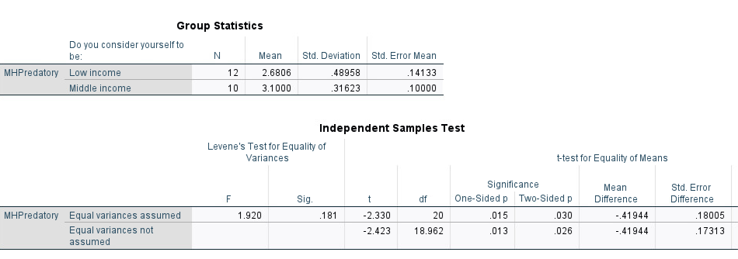  
*Figure 1*

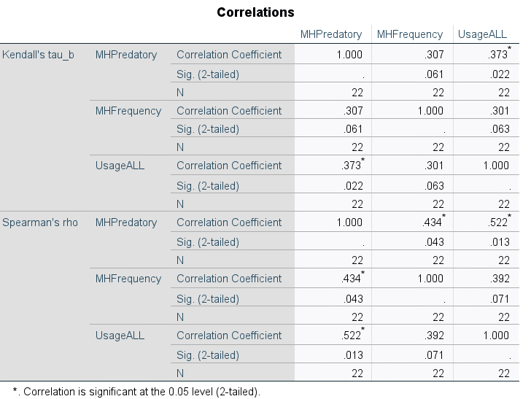  
*Figure 2*

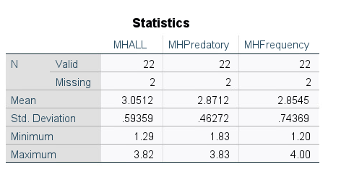  
*Figure 3*

  
*FIgure 4*

  
*Figure 5*

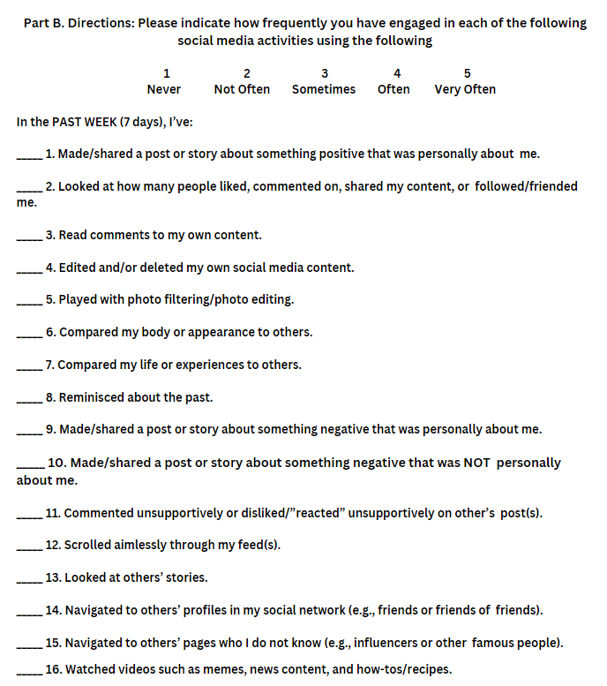

*Figure 6*

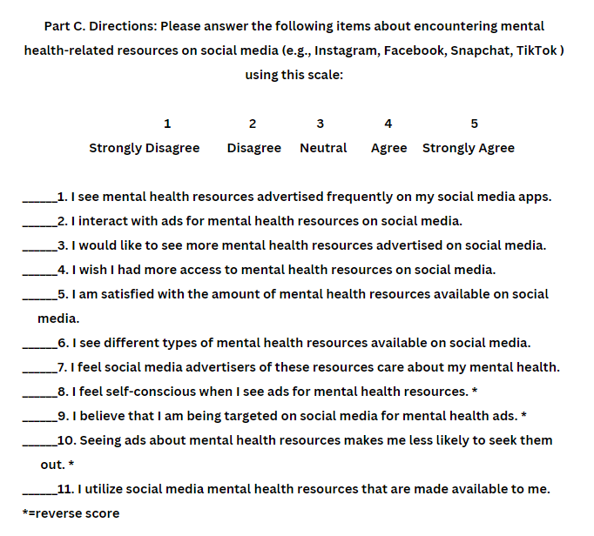

*Figure 7*