***Calling Out Comedy: An Exploration of Misrepresentation in Animated Short Films***

Abbey Willmann, Rhy’ss Taylor, Jacob Miller

Department of Communication

COMM 7002: Mediated Communication and The Individual

Dr. Nancy Jennings

December 10, 2022

**INTRODUCTION**

The American animation industry is a major player in children’s entertainment, and it has played a part in entertainment for longer than most Americans today have been alive. Like most forms of entertainment, animation often reflects the ideas or social norms of the time in which it was created. Because of this, much of animation in the 20th century is infused with negative stereotypes surrounding minorities, women, and cultures foreign to America itself. Have the frequency of these stereotypes lessened over time, or do they still exist in the animation industry today?   
 Through *cultivation theory* (the study of media’s effects on viewers), we can see that the media a person engages with influences their own personal set of beliefs. The heavier the viewership of television or media in general, the greater the effect on the individual. If a person engages with a lot of crime television for example, they will believe that the world is a much scarier place compared to a person who just watches comedy specials. This study will also include *critical race theory*, to discuss how comedic relief characters are represented in animated films and will be further utilized to assess the overall impact of these individual coders and how they have contributed and been translated into humanity. Having an effect on the viewers isn’t something that is genre exclusive however, and it can be applied to animated content as well. Animated content often uses humor as the main source of entertainment for the viewer, though throughout much of the 20th century and into the 21st century, it appears a great deal of humor is based on negative stereotypes.

Representation in media for minorities and women in the early 20th century was limited, and the roles they were given were stereotypical roles at best. This constrained the characters, limiting their ranges and personalities, and prevented them from having a larger impact on the plot of the media itself. It also helped lead audiences to continuing the belief in these harmful stereotypes about both minorities and women. While these stereotypes were pervasive in animated media of the 20th century, this study seeks to examine if those stereotypes are continued today in our current society and entertainment industry. Studying the topic of negative stereotypes and how pervasive they were in animation can help us to understand and prevent negative stereotypes from being spread or depicted in the future.

Our study seeks to examine and measure depictions of racial stereotypes in animated short cartoons from the 1930s, up until the 2010s, covering most of the history of animation. By examining ten different short films/animated episodes, we can record and measure negative stereotypes and depictions in popular animated media. By doing this, we can determine if the frequency of negative stereotypes in animated media has lessened, remained the same, or increased in the almost century long run of animation in The United States.

**REVIEW OF LITERATURE**

In a study titled *The Good, The Bad and The Foriegn*, two researchers studied 12 different television programs airing in 1996, coding characters based on personality, appearance, dialect and their accents. Our study seeks to study a similar element of animation, covering cartoons of different decades. In their study, they determined that “the majority of characters in children’s animated television are still young, male and anglo-saxon.” (Dobrow & Gidney, 1998, p. 117) They continued, stating that there appears to be a trend towards a more racially diverse cast in more recent television programs, in addition to more women being represented in children’s animation. Another notable point of interest was this study’s examination of race and beauty regarding heroes and villains. Villains would often have noticeable accents, be overweight and have darker skin tones. Though in more contemporary media, this seems to have faded with time, a result we hope to see in our own study.

Sarah J. Hoffman’s master thesis, *Not Just Entertainment: Hollywood Animation and the Corporate Merchandising Aesthetics and Narratives for a Children’s Audience,* Hoffman examines the works of Pixar, Disney, and DreamWorks and how they play a role in shaping ideologies. She states that Disney uses “formulaic narratives and songs as the primary means to establish a Disney ideology shared among generations of Disney consumers.” (Hoffman, 2017, p. 10) Hoffman also states that early works by Disney depicted heroes as lighter skinned beautiful characters, and villains as darker skinned or ugly. This study shines a light on something we seek to research, the role cartoons play in the shaping of ideologies.

In another study, titled *Cartooning humor: How Arabs are laughably derided in animations: An international journal of pure communication inquiry,* Mohamed Belamghari examines cartoon depictions of Arabs in the 1930s and 1940s. He states that “...through comical humor in animated films, cartoon producers tend to amplify the implementation of stereotypic, anachronistic, and anecdotal features of Arabs, which could also have long-term destructive consequences to both Arabs and Westerners…” (Belamghari, 2015, p. 65) showing that depictions of negative stereotypes can create larger consequences. The two pieces examined in this study, *Popeye the Sailor Meets Ali Baba and his Forty Thieves* and *Ali Baba Bound,* both depict Arabs are violent stereotypes, and only contributed to xenophobia of the time. This study played an important role in our selection of cartoons for our study, which includes cartoons dating back to 1935.

In *Doc McStuffins and Dora the Explorer: representations of gender, race, and class in US animation* by Jobia Keys, Keys examines misrepresentation in two different female, minority led shows. Here, both main characters complete acts that are typically more masculine in previous depictions, including math and science proficiency. Both characters have bits of stereotypes from their given communities, but also exist to challenge these stereotypes. Keys states that “the intersectionality of race, gender, and class in these characters largely challenge stereotypes, help to define them, and usher them into normativity” (Keys, 2016, p. 366) regarding the programs’ main characters. Our study seeks to examine protagonists of the past and present, to find characters that both represent and challenge stereotypes, just as Keys did.

Finally, in *Racial Representation in Western Animation: A Media Influenced By History and Society* by Nur Liana Mohd Redzuan Roy and Nora Edrina Sahharil, portrayals of characters within contemporary animation are examined. Here they are examined for the important role they play in the development of future representations in Western media. They argue that Disney and Cartoon Network in the mid 2000s have greatly advanced positive representation of minority groups in children's animation. In their conclusion, they state “the erasure or complete disregard of past animations should not take place as these representations along with modern depictions both have an importance in shaping the industry and shows to come.” (Roy, Sahharil, 2020, p. 568) This is also something our own study hopes to highlight. Acknowledging and not forgetting the past of animation is very important, not only to remember, but also to help prevent negative depictions of race and gender in the future.

**METHODS**

This study will focus on 10 popular children's animated short films, five of which were produced in the 20th Century, while the other five films were produced in the 21st Century. Specifically, the sample will look at five films from the 20th Century that depict and utilize characters of foreign or non-White characteristics and attributes. Using this idea, the second half of the sample containing films produced in the 21st Century will be used to compare and contrast contemporary and past productions to further analyze how the films depict specific characters and the effect these representations may have on adolescent audiences. The sample will be filtered out through a popular rating scale (a rating of five stars and higher), year of production, film length (20 minutes or less), and TV rating on the IMDB movie site. This study will focus on the basic principles of content analysis and utilize four main coders in order to adequately assess each film’s possible impact on past and current culture. These coders will consist of; the attributes of the character (gender, race, age), the amount of screentime of the character, the dialogue of the character, and the year the production was created.

This study applies *critical race theory* to discuss how comedic relief characters are represented in animated films and will be further utilized to assess the overall impact of these individual coders and how they have contributed and been translated into humanity.

Operationally, the attributes of the specific character or characters will be contextualized and divided into several subcategories: clothes, height, whether they show characteristics of rebelliousness, and cognitive abilities in order to measure specific stereotypes. The sample will also be accessed by the amount of screentime of the character(s) to compare humorous or non-White characters' time on screen by contrast of their more serious or White-fronting counterparts. These characters will be visually observed according to the (more than 3 minutes) scale as visited by Banjo and Jennings (2017) in *Content Analysis of the Portrayal of White Characters in Black Films Across Two Decades.* These non-White characters falling within the linguistic and racial guidelines, will be individually assessed in order to examine the amount of screen-time given to each of these characters per film. The dialogue of these characters will be contextualized by how many times they speak, the dialect in which they speak, as well as the context of their lines. Each character's dialect will be accessed using Dobrow and Gidney’s (1998) linguistic assessments. The sample will further review the dialogue in the films by observing powerful and powerless speech to and from these characters. Depending on the specific dialogue of non-White characters and how they converse between their counterparts and other characters within the films, the dialogue will then be placed into the sub categories: aggressive speech, powerless speech, and powerful speech. This topic is further discussed by Layng (2001) when diving into the powerful speech among Disney heroines such as Snow White and Jasmine. The characters will be identified as unfavorable or favorable to the plot, initiating a general understanding of how important and practical the character is to the story. This will reveal the trends in whether characters of diverse race, ethnicity, and gender are portrayed as dignified and essential characters to the overall plot of many short films. Character actions and dialogue will be deemed as unfavorable when the character shows no helpful attributes to conclude the story and is represented with unfavorabel clothing, dialogue, and attitude. Characters will be identified as favorable when their actions are accompanied by protagonist success, their clothes are fully covering their body, and their characters’ race or ethnicity is not accompanied by stereotypical properties. The sample will also be categorized by the year the production was created to compare and contrast between contemporary and past animation.

**RESEARCH QUESTIONS**

This study is guided by the following research questions:

RQ 1: How can comedy be transformed into disrespect in animation?

RQ 2: How does misrepresentation in animated films perpetuate racist and discriminative ideals to its audience?

RQ 3: By contrast to their counterparts, how are comedic relief characters treated differently in animated films?

RQ 4: How does comedy affect the popularity outcome in animated films?

RQ 5: How has there been an increase in proper representation of non-White individuals in the short films of the 21st century compared to that of the 20th century films?

**RESULTS**

To test whether there has been a growth in diversity between the 20th and 21st century within the realm of animated film, an analysis of ten short-animated films was performed. In the ten animated films analyzed, we identified a total of 40 characters. Out of this pool, 23 of the 40 characters (57.5%) were deemed as White, while only 17 of the 40 (42.5%) were deemed as non-White. Prior to conducting this analysis, we asked a series of research questions. In order to answer the first research question about how comedy can be transformed into disrespect within animation, an analysis of character attributes collected by our team was conducted to examine whether characters of non-White backgrounds in the 20th century had fallen victim to racially-biased content. *The most prominent results of this study can be found in Figure 1 and Figure 2.* Our data shows that non-White characters highlighted in short films in both the 20th and 21st century contained a more unfavorable attire and attitude, as well as lesser role in dialogue than that of their White counterparts. (*See Figure 1*).

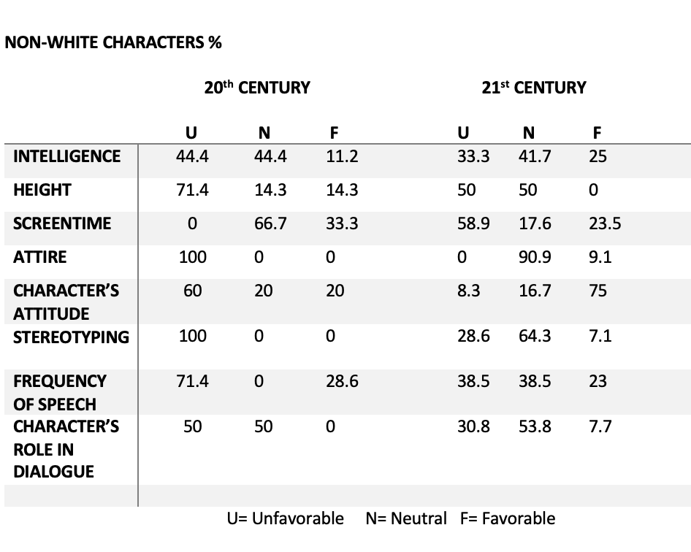

*Figure 1*

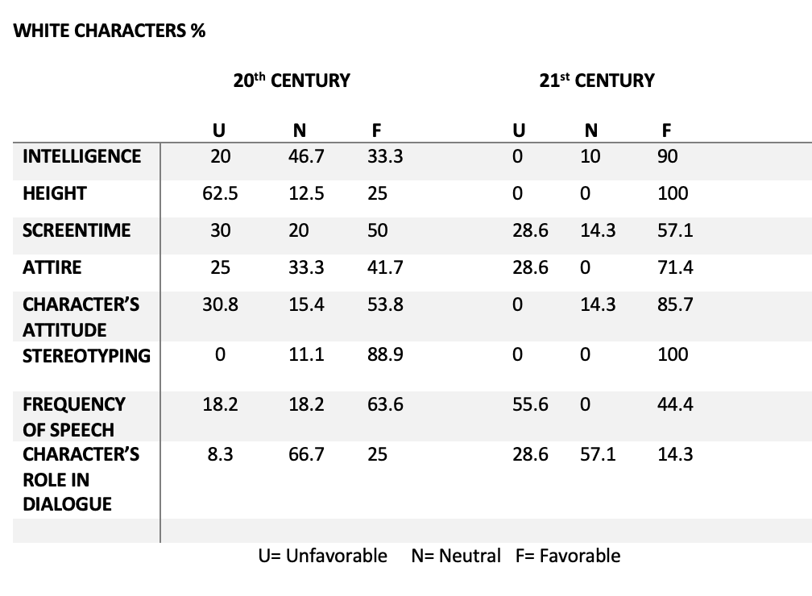

*Figure 2*

In addition, we noted the significant differences between the frequency of speech experienced by White and non-White characters. Characters of non-White backgrounds in the 20th century experienced much less availability to speak, and were also recorded to have been most looked down upon by other characters (50%). Powerless speech is a repeated trend throughout the short films, as many characters suffer from the lack of dialogue, leading to their lack of self-representation and identity. This aspect correlates with our second research question about how misrepresentation in animated films perpetuates racist and discriminative ideals to its audience. To answer our third research question of how comedic relief characters are treated differently in animated films in contrast to their counterparts, our team examined that characters labeled as “humorous” had more of an unfavorable role in dialogue when compared to their non-humorous counterparts. 21 of the 40 characters studied throughout the ten animated short films were labeled as “humorous.” In addition to this, 56.3% of comedic characters in the 20th century films examined were that of non-White descent in comparison to the 80% of non-White comedic characters located within the 21st century films studied.

While the majority of characters with comedic roles were of non-white background, many of the films also only contained non-white characters. Of our sample, films containing the majority comedic characters did not see higher correlations of critic’s ratings. For instance, the short film, *Jamie Lo* was given a higher rating than films containing more comedic than non-comedic characters. Overall, films containing less humorous characters received higher ratings from critics. Films such as *The Little Match Girl* (2006) and *Paperman* (2012) contained no humorous characters and both received higher critic ratings compared to their comedic counterparts, such as *Private Snafu: Spies* (1943) and *Coal Black and De Sebben Dwarfs* (1943) which each received a relatively low rating.

In order to answer the final research question of whether there has been an increase in proper representation of non-White individuals in the short films of the 21st century compared to that of the 20th century, our team utilized our coded data to interpret whether stereotyping was more prominent in the earlier films or the latter. Out of the 20th century films examined, 12 out of a total 22 characters were deemed as non-White. Within this category, 100% of these characters were labeled as pertaining to a certain stereotype. (*See Figure 1*). Out of the 21st century films examined in this study, 11 out of a total 18 characters were labeled as non-White. Within this category, 28.6% of the 61.1% non-White characters were accused of pertaining to a certain stereotype. (*See Figure 1*). Of the films that we examined, we can confirm that films in the 21st century are moving towards more positive depictions of race and gender, but don’t completely lack depictions of stereotypes just yet.

**DISCUSSION**

This experiment provides a new insight into the relationship between animated short programming of different decades and how they pertain to existing and perpetuating stereotypes of minorities and lower class individuals. While previous research has focused on dialects within children's media, such as content authors Julia Dobrow and Calvin Gidney examine in their previous research, the results of this study perhaps lay the future groundwork for composing a path towards inclusive, minority-led dialogue and context in animated film. By analyzing character attributes of various motion pictures, our team was efficient in gathering data in order to offer a comprehensive analysis pertaining to the disparate effects of minority representation in animated films. By first calculating the percentage of comedic (52.5%) to non-comedic (47.5%) characters within the ten films analyzed, we were then able to break down the percentage of which these humorous characters were of a non-White background (57.5% *theory*, our team assessed trends in the data that allowed for us to evaluate how minority and non-minority comedic representations affect the outcome of a critical rating and overall success of the film. Our research supports the theory that the addition of ). Utilizing *cultivation* humorous characters does not have any positive correlation to critic rating and success. While some of the short films analyzed were both successful while containing multiple humorous characters, our team found that the most successful of these short films contained a majority of non-white and non-comedic characters, with the exception of *Paperman* (2012) and *The Little Match Girl* (2006) which contained no humorous or non-white characters. Another important analysis made by our team in this study is the powerless/powerful speech exemplified in the animated short films. While many films contained no dialogue, those that did often contained speech that belittled or spoke down upon characters of a minority population. For instance, 50% of minority characters received an unfavorable role in dialogue amongst the 20th century films examined.

In addition, the results of this study build upon the work of Jobia Keys, who discusses the importance of feminine representation within Children’s animation in her essay, *Doc McStuffins and Dora the Explorer: representations of gender, race, and class in US animation.* Films such as *The Little Match Girl* (2008) showcase the success and prosperity that can come of adding female characters to the screen. In this study, female characters held over half of the total screen time in the five of the 21st century films studied. In the films of the 20th century, the women depicted on screen were either represented as erotic, such as Betty Boop, or immensely lacked adequate screen time, such as Popeye’s mother. The shift in positive female representation within the 21st century short films will aid in the shaping of forward-looking ideologies, much like those discussed by Keys.

While our methodological choices were constrained by the lack of prominent short films and time, our findings suggest a clear rise in productive and useful minority representation within animated filmmaking. Further research could expand upon the significance of non-human like characters as representations of non-white beings as well as how cast and director culminate minority representation. The results collected in this study are extremely valuable for maintaining diverse and well-represented media, as well as drawing attention to negative depictions of minorities and women in animation of the past.

**CONCLUSION**

Due to the lack of proper representation in film and an inadequate understanding of how minority populations exist in American society, minority groups continue to experience the perpetuation of stereotypes antagonized by many animated productions. Misrepresentation in animated films can feed into the audience's racial and discriminatory views, which are then reflected in various facets of society itself. Animation makes it possible for characters to be styled in a variety of ways. As a result, animated movies can influence viewers' perceptions of various identities by emphasizing various characteristics, dialogues, and behaviors. To explore the effects film has on the perceptions of non-White individuals in Western culture, our team coded 10 animated short films. Each of these films were coded based upon characteristics of the film, attributes of the characters, as well as the overall success of the film. By studying films of both the 20th and 21st century, our research was able to gauge how diversity within film has shifted overtime, and how the success of the film can correlate with the films’ inclusivity.

After collecting and analyzing data, the study confirms a positive shift in minority representation within the field of animated shorts. Our research also shows that while many animated films utilize non-White individuals as a form of comedic relief, it does not positively correlate with the film’s success.

The data collected in this study may contribute to the push for equality and accurate portrayals of minority populations within contemporary filmmaking. This study may also contribute to the significance and further study of how powerless and powerful speech take shape within present-day media.

**REFERENCES**

**Articles:**

Dobrow, Julia R., & Gidney, Calvin L. (1998). The good, the bad, and the foreign: The use of dialect in children's animated television. *The ANNALS of the American Academy of Political and Social Science*, *557*(1), 105–119.

Roy, N. L., & Sahharil, N. E. (2020). Racial representation in Western Animation: A media influenced by history and Society. *International Journal of Academic Research in Business and Social Sciences*, *10*(12)

Keys, J. (2016). Doc Mcstuffins and Dora the Explorer: Representations of Gender, Race, and Class in US Animation. *Journal of Children and Media*, *10*(3), 355–368.

Belamghari, M. (2015). Cartooning humor: How Arabs are laughably derided in animations: An international journal of pure communication inquiry. Kome, 3(2), 64-74.

Hoffman, S. G. (2017). Not Just Entertainment: Hollywood Animation and the Corporate Merchandising Aesthetics and Narratives for a Children’s Audience [Master's thesis, Ohio University]. OhioLINK Electronic Theses and Dissertations Center.

**Films:**

Anderson, H., & Allers, R. (2006). *The Little Match Girl* . *The Little Match Girl - A Short Film* . Disney Plus . Retrieved December 9, 2022, from <https://www.disneyplus.com/video/ff25de29-e0e8-4989-b60b-f2838fe21de0>.

Fleischer, D. (1935, October 18). *Betty Boop- making stars*. IMDb. Retrieved December 10, 2022, from https://www.imdb.com/title/tt0026669/

Chen, L. (2006). *Jaime Lo, small and shy*. IMDb. Retrieved December 10, 2022, from https://www.imdb.com/title/tt1546000/

Clampett, R. (1943, January 16). *Coal black and de sebben dwarfs*. IMDb. Retrieved December 10, 2022, from https://www.imdb.com/title/tt0035743/

Jones, C. (1943, August). *Spies - Private snafu*. YouTube. Retrieved December 10, 2022, from https://www.youtube.com/watch?v=Ws9L-Kifjkg

Kahrs, J. (2012). *Paperman*. *Disney Plus* . Retrieved December 9, 2022, from https://www.disneyplus.com/movies/paperman/2PQQQssQ8Gf6.

Kneitel, S., Johnson, T., & Sparber, I. (1952, January 25). *Popeye's Pappy*. IMDb. Retrieved December 10, 2022, from https://www.imdb.com/title/tt0152036/

Layng, J. M. (2001). THE ANIMATED WOMAN: The powerless beauty of disney heroines from snow white to jasmine. *The American Journal of Semiotics, 17*(3), 197-215. Retrieved from https://uc.idm.oclc.org/login?qurl=https%3A%2F%2Fwww.proquest.com%2Fscholarly-journals%2Fanimated-woman-powerless-beauty-disney-heroines%2Fdocview%2F213749805%2Fse-2%3Faccountid%3D2909

Lester, K. (2009). *Purl*. *Disney Plus*. Retrieved December 9, 2022, from https://www.disneyplus.com/movies/purl/3FTOSVXXf7tl.

Patterson , R. (1960). *"mister Magoo" A day at the beach*. IMDb. Retrieved December 10, 2022, from https://www.imdb.com/title/tt1265851/

Shi, Domee, director. *Bao*. *DisneyPlus*, Disney Pixar , 12 Apr. 2018, https://www.disneyplus.com/movies/bao/2NOY3PbUN9os. Accessed 9 Dec. 2022.